**INFOLABZ IT SERVICES PVT. LTD.**

**Course :** React

**Session No :** 13

**Topics to be covered :** Js inside react

JS : Basically entire react is js

For example : App.js , Index.js , Custom.js, xyz.js

* All the code you write in this file consider as js
* The code you return could be html code

1. **Local** : code , variables etc that could be used in particular component only

App.js

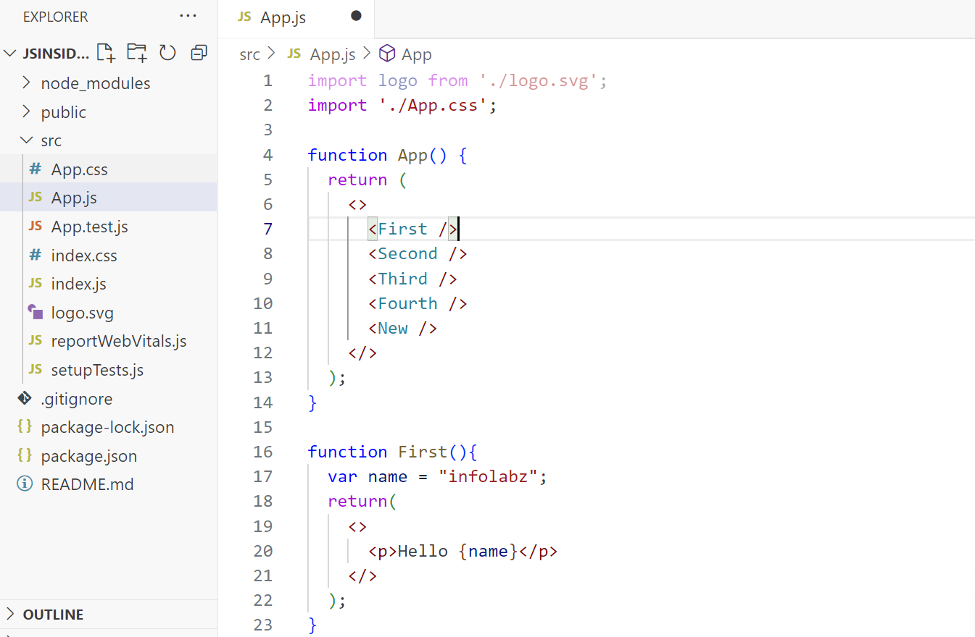

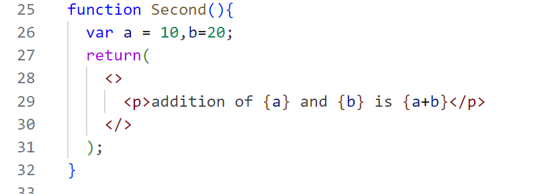

1. **Global** : code , variables etc that could be used in any components

App.js

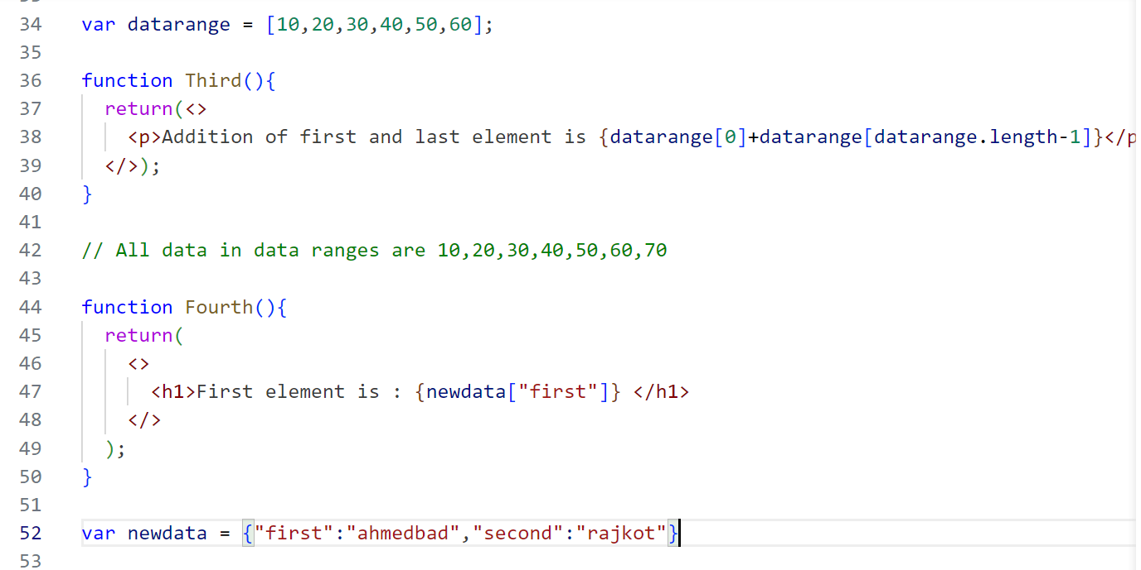

// cities are : print all cities

